Newton Poppleford School Association (PTFA)

Summer Term 1 meeting minutes 2024

**Attendees:** Teri Murphy (Chair), Henry Odbert (Deputy Chair), Georgia Trengove (Secretary), Jon Leeson-Kings (Treasurer), Katy Evans, Bob Tubbs, Kate Clemens, Kelly Rogers, Laura Broughton, Magdalena Oprea, Rebecca Burdus, Roberta McLeod, Sarah Furzer, Tanisha Ellis, Gemma Joyner, Emily Wiley, Anna Oldroyd, Camille Harman, , Chloe Pawson-Pounds, Morgan Wilkinson, Jo White, Janine Rudling, Helen Tubbs, Kirsty Rorke.

**Welcome**

This is the virtual meeting group to discuss all matters PTFA and fundraising related, anyone is welcome to join by contacting Teri Murphy 07909 798441.

**Funding requests and purchases**

**Easter 2024**

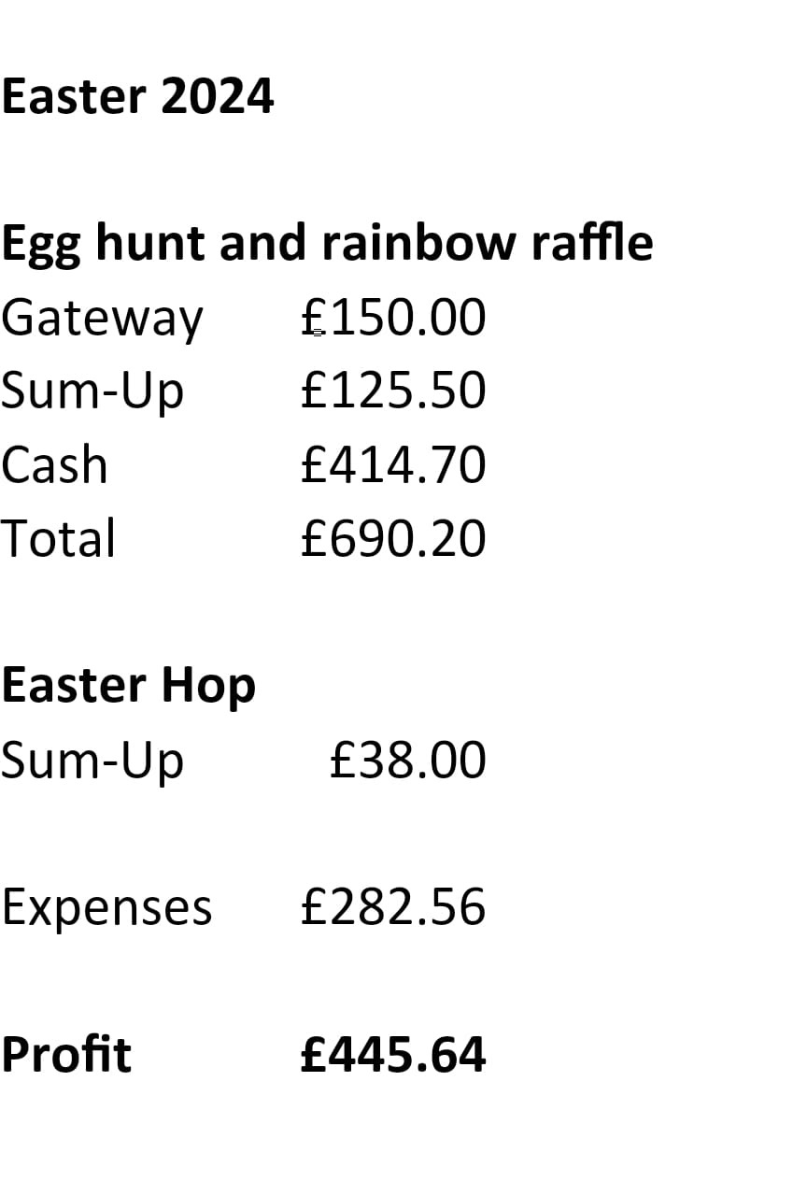

Laura Broughton very generously donated a box of Looby’s Kitchen brownies to the winner Adam Westaway for completing the Easter Hop.

**Plan for the term**

Here is the PTFA event plan for the Summer Term:

* Summer Fete- the date booked for this Friday 28th June 2024 and it will be after school in the playground.
* Summer Disco- this will be the last week of this half term (W/C 20/05) Mr Pope is going to confirm what dates we have to choose from to work around after school clubs.
* Cake Sales- Wewhave Year 1, Reception and Preschool sales booked in this term.
* Cocktail Night- plans are afoot for a grown up only mixology masterclass, hopefully this term.
* Book Fair- school have given the PTFA two options and Teri has decided 10th June because then it give the PTFA more time to market the event and also we don’t lose a day to inset. The book fair is booked with Scholastic.
* Break the Rules Day- a vote was taken and 7th June won with 7 votes.
* Freezy Fridays- this was a success last year and we agreed to do it again. Georgia will create a rota of helpers.

The Summer Fete will be discussed in this group. The cake sales are in the capable hands of the class reps. If you would like to be more involved in the planning of the disco or cocktail night please let Teri know and you can be added the specific whatsapp groups for these events.

**Cake Sales for 23/24**

Teri has added a spreadsheet to the drive with all the cake sale income, class spend and approved funding requests.

12th October - Year 6 £118 raised. Cash added for people who missed the cake sale therefore new total is £124.90

9th November - Year 5 £162.50

18th January - Year 4 £183.50

29th February - Year 3 £222.50

21st March - Year 2 £223

25th April - Year 1 £181

16th May – Reception £257

20th June - Preschool

**Disco**

Mr Pope has confirmed 3 dates that the disco can go ahead: 20/5, 22/5 or 23/5. The 23.05.2024 was the date with the most votes (10 votes) therefore this has been chosen as the date for this terms disco. Georgia has asked for volunteers for prizes and helpers for the disco. They will be added to the disco whatsapp group and delegated specific roles.

**Book Fair**

This is the week commencing 10th June. It will be open every afternoon afterschool and will need volunteers to run it and to set up the books on the Monday morning. Georgia is going to organise and rota for this event.

**Sheds**

Anna has offered her shed to the PTFA and very kindly Dom Welch has collected it and delivered it to the school playground.

**Cocktail Night**

Update: Cocktail Night has been bumped into the next academic year due to other commitments.

**Break the Rules**

Rules that can be broken approved by Mr Pope:

* School uniform must be worn
* No face paint or makeup
* No nail varnish
* No temporary tattoos
* No crazy hair styles
* No hats in class
* No large cuddly toys in the classroom
* Don’t eat pudding first at lunch time
* Only healthy snacks at break time
* No squash in water bottles

**Art Raffle**

Amy Sweet is organising prizes for the Art Week in school. Also whilst Amy was finding raffle prizes Winstones book shop also mentioned to her about the book wish list the are doing for the local schools where schools can give them a wish list of ten books that they would like for their library and then customers can buy them for the school. Amy is going to talk to Mr Pope about setting up this for the school.

**Summer Fete**

Teri has asked for any new ideas or anything that we should definitely do again this year,

**Recruitment**

At the next AGM in October 2024, the PTFA needs committee members.

* TREASURER: After many years in this role, Jon will be moving on as his youngest son transitions to secondary school. Please have a look at the attached job description and contact me or Jon for an informal chat if you'd like more information. A full handover and ongoing support will help you settle into this role!
* SECRETARY : Again, please look at the attached job description, or have a chat with Georgia about the role. Full training and ongoing support are on offer!
* CHAIR PERSON: If anyone would like to put themselves forward as the chair of the PTFA, then please have a look at the attached job description and contact Teri for an informal chat. Teri will provide my full support and there can have as lengthy a handover as you'd like. Alternatively, if anyone would be interested in a CO-CHAIR position, or a DEPUTY CHAIR role, then please speak to Teri.

There's a possible cabinet reshuffle we can orchestrate at the Autumn AGM, but the committee definitely need to recruit AT LEAST ONE new committee member.

**School Lottery**

We have a weekly winner and the chance to win £25,000 plus non-cash prizes. Visit [www.yourschoollottery.co.uk](http://www.yourschoollottery.co.uk) to buy tickets.

**Easyfundraising**

Easyfundraising.org.uk is still working though so please suggest this a shopping portal for online shopping and effortlessly donate to the PTFA.

-Anyone can join this group by contacting Teri Murphy, Chair 07909 798441