Newton Poppleford School Association (PTFA)

Committee Meeting Minutes – Virtual meeting via WhatsApp

Summer Term 1 2024

**Attendees**: Teri Murphy (Chair), Henry Odbert (Deputy Chair), Georgia Trengove (Secretary), Jon Leeson-Kings (Treasurer), Kate Clemens. (exiting secretary)

**PTFA funding requests and purchases**

Year 2- Plymouth Aquarium visit- £313 (coach allowance and cake sale)

Reception- Seaton Wetlands- £150

Year 1-Coach to Brixham- £250 (coach allowance and cake sale)

EYFS and KS1- 295 reading books- £295

Preschool- Animal Encounters- £240 (coach allowance and cake sale)

**Cake Sales for 22/23**

Teri has added a spreadsheet to the drive with all the cake sale income, class spend and approved funding requests.

12th October - Year 6 £118 raised. Cash added for people who missed the cake sale therefore new total is £124.90

9th November - Year 5 £162.50

18th January - Year 4 £183.50

29th February - Year 3 £222.50

21st March - Year 2 £223

25th April - Year 1 £181

16th May – Reception £257

20th June - Preschool

**Easter Profit**

Last year the PTFA did a full fete and raised £560 so Teri is chuffed with how much the PTFA raised from the mini version.

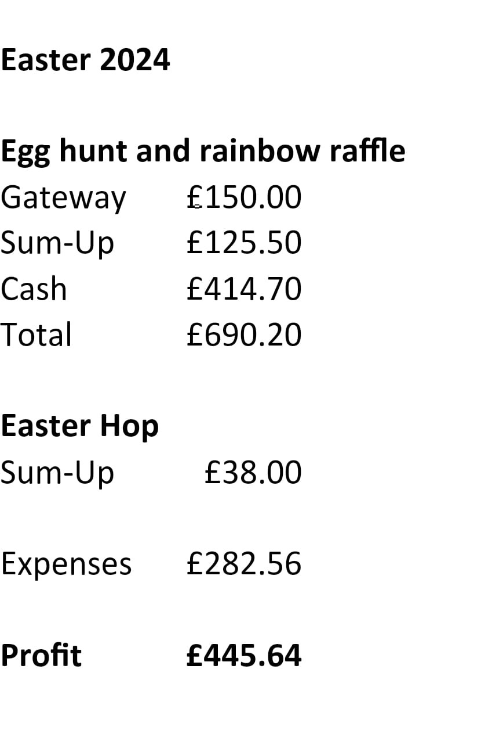

**Year 5 Eden Project Trip**

Mrs Bradley would like to take Year 5 to the Eden Project but the total cost is expected to be around £800 which would mean that each pupil would have to pay around £28 each. Mrs Bradley would like the PTFA to subsidise £290 therefore parents would be asked to pay £18 towards the trip instead which is more affordable. The PTFA committee discussed that we would take each case and if we had enough money try and support every trip or learning experience. Therefore, we have agreed to subsidise the trip.

**Summer Fete**

Henry has been looking at the different options for the Summer Fete School Raffle and has found some for £38 for 3000. Teri recalled that we ordered 3000 in 2022 and had to panic print more, we ordered 4000 in 2023 and were fine so order 4000 again this year. The Committee also discussed how the BBQ hasn’t done as well the last few years and possibly having something different this year eg. pizza van.

**Committee meeting**

Teri, Georgia and Henry had a quick meeting to discuss the changing roles next year in the PTFA Committee with Jon leaving, Teri taking a lesser role and Georgia stepping into a co-chair role with Teri will mean that the committee will need to fill the roles of secretary and treasurer. Henry has agreed that if no one steps forward as treasurer then he will fill the role temporarily. The committee discussed sharing the PTFA roles with the wider year group whatsapp groups and if no one comes forward this will be shared in the whole school community.

**Storage for PTFA**

Teri has updated the committee and confirmed with Adrian that the PTFA can have the unit in the bike shed to use as part of the book shed. The gravel needs to be moved outside Year 2 classroom.