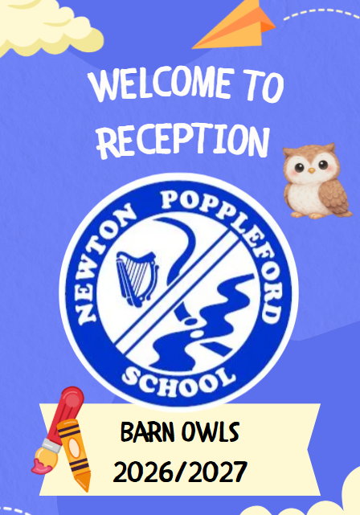
Absences – If your child is absent from school, please contact the school office before 9:10 to inform us. If we have not been contacted, the school administrator is required to phone home to find out where your child is. We hope you can appreciate the safety issue involved here.
Adventure Island – Our sessions at AI will be on Monday afternoon. Please leave a spare pair of wellies on the outside pegs and waterproof trousers or a waterproof all-in-one as we use wellies/waterproofs every day.
Beginning of the day – Please come in the main gate and go down the path to the right of the school building. The path will take you to the lower playground. The children will come into the classroom on their own and self register at 8.45am. The morning is busy and we focus on settling children into school at the beginning of the day but feel free to pass on a message - if you wish to talk to us at length, please see us after school. Messages can also be written in the Home/School Book or on Tapestry.
Breakfast Club – This is run from Monday to Friday from 8:00 am in the library. Toast, cereals, fruit, and milk are made available. Please let the school office know if you wish to make use of the club.
Buddy – Your child will have a Big Buddy from Year 5 who will help them settle into school.
End of the day – The children will be sent out to meet you from the classroom at 3:15 pm. Please wait for them in the area outside our classroom. If someone else is picking your child up, you will need to make sure they are on the approved list held in the office for this. Please let the school office know or put a note in the home school book.
Illness – Please let us know when your child is ill and if the illness is an infectious one. If a child has had sickness or diarrhoea they are required to remain off school for 48 hours from the last occurrence.
Medicines – An ‘Administration of Medicines in School’ form is available from the school office and will need to be completed for any medicines we give.

Packed lunches – Please do not include chocolate spread/jam sandwiches, sweets, chocolate, and fizzy drinks. Please avoid any food containing nuts and sesame seeds including hummus as we are a nut free school.

Parents’ meetings – Individual meetings with Mrs Raffell, will be arranged at the end of the first half of the term. It will be an opportunity to talk about how your child is settling into school.
Parent Support Advisor – For confidential advice, support and information, Fiona Pyle is at the end of a phone. Please feel free to call Fiona, who is based at Sidmouth College. Her contact details are 01395 514823 ext 234. Fiona also hosts our ‘Care Café’ which is a drop-in session with our SENDCO generally on the first Monday of the month in the library.
Parent Teacher Friends’ Association – All parents are members of the PTFA and are welcome to take an active role in it by attending meetings and helping with the events that are organised.
PE kit – In Reception, we don’t change for PE in line with our PE policy.
Reading Diary – Your child will come home with this yellow book each day. The book is a way to record what books they have read and how they have got on with their reading, along with their magnetic spelling games.
Rewards - As a school, we give out certificates in Celebration Assembly every other week. We have a Golden Star in our class that the children will be recognised for all sorts of things. Your child will also be placed in one of our four school tribes, Red, Blue, Green or Yellow.
School dinners – A menu for the term will be sent to you and is available on our website. Currently, your child will receive a free school meal. At the beginning of a week please let us know if your child is having the vegetarian option, a jacket potato and what fillings or a packed lunch, via your MCAS App. If we don’t hear from you we will assume they are having the main option.
Snack – The children in Reception and Key Stage 1 are provided with a break time snack of fruit or vegetables. There is no charge for the snack.
Sun hats and sun cream – Please provide these for your child as soon as the weather warrants it. We can help your child to top up their sun cream, but please could you apply some thoroughly before he/she comes to school. Caps are available to buy from the school office, but you can use other sun hats. Please name hats and sun-cream bottles.
Take-home bags – We give out a plastic reading bag to keep everything in. NO BIG rucksacks please as our peg space is very limited.
Tapestry- This is our online journal and a way of communicating with you about how your child is progressing in reception. It is a great way to send messages about lunch options or if someone else is picking up your child. Photos of your child will be posted on your account and you can also put
photos of your child when they do something at home to share with us. Please complete the online form to enable us to set up your account asap.
Toys - Children can bring a small toy into school if they choose but they are responsible for it. It can stay in their coloured box when they come in in the morning.
Twilight Club – This runs from Monday to Friday from 3:15 pm to 5.30 pm, in the school hall (5.00 pm on Friday). Toast, fruit and a drink are made available. Places need to be booked via the school office. There is a sliding scale of charges. Please enquire in summer for the first 3 weeks of autumn term.
Uniform – A waterproof coat is a necessity, even in the summer! Please name all clothing. Shoes should provide good support for your child’s feet. More details relating to our uniform are contained in the School Information Booklet.
Water bottles – We want water to be available for the children at all times. The Parent Teacher Association is kindly providing water bottles for each new child. In our class, the bottles will be filled, emptied and cleaned for the children.
Website & Facebook – You can keep up to date with news on our school website, class webpage and school Facebook page. You will also receive our online newsletter ‘School Matters’ every other Friday.

